CS 305 Project One Template

Document Revision History

Version | Date | Author | Comments
1.0 | [5/22/2026] | [Romi’on Price]

Client



Instructions
Submit this completed vulnerability assessment report. Replace the bracketed text with the relevant information. In this report, identify your security vulnerability findings and recommend the next steps to remedy the issues you have found.

- Respond to the five steps outlined below and include your findings.
- Respond using your own words. You may also include images or supporting materials. If you include them, make certain to insert them in the relevant locations in the document.
- Refer to the Project One Guidelines and Rubric for more detailed instructions about each section of the template.

Developer
Romi’on Price

1. Interpreting Client Needs
Determine your client’s needs and potential threats and attacks associated with the company’s application and software security requirements. Consider the following questions regarding how companies protect against external threats based on the scenario information:

- What is the value of secure communications to the company?
- Are there any international transactions that the company produces?
- Are there governmental restrictions on secure communications to consider?
- What external threats might be present now and in the immediate future?
- What modernization requirements must be considered, such as the role of open-source libraries and evolving web application technologies?

Artemis Financial is a consulting company that develops financial plans for its customers, plans such as savings, retirement, investments, and insurance. Artemis handles classified personal information, making the value of secure communication vital for this company. The company doesn’t imply that it only does domestic transactions or plans for its customers, it’s safe to assume that they also deal with international transactions. There is an absence of restrictions whether it being federal or state restrictions on secure communication, maintaining secure security measure is essential for protecting customer information. Data leaks might be the main threat both now and in the immediate future if data like addresses, accounts, names, social securities, etc. aren’t properly secured or encrypted. Keeping their libraries secure and updated is crucial, ensuring bug fixes or patches are applied to areas that contain vulnerabilities.

2. Areas of Security
Refer to the vulnerability assessment process flow diagram. Identify which areas of security apply to Artemis Financial’s software application. Justify your reasoning for why each area is relevant to the software application.

Input Validation: Ensures code isn’t vulnerable to exploits like SQL injections or Scripts, ensures data integrity

APIs: Makes sure that interactions are secure, a strong API is necessary for end users. Must ensure interactions are secure, especially if any interactions with third party software occur.

Cryptography: Data must be properly encrypted; customer information is top priority. Necessary for securing customer information during international and domestic transactions.

Code Error: Effective error handling is needed, should complement input validation and API processes. Proper handling will prevent unauthorized access to information.

Code Quality: High quality code is vital in preventing unauthorized access or data exposure. Should maintain secure interactions with end users’, especially with input and API usage.

3. Manual Review
Continue working through the vulnerability assessment process flow diagram. Identify all vulnerabilities in the code base by manually inspecting the code.

[Include your 7–10 findings here.]
- Improper to no input validation was found in the code. Especially in the greeting controller file which uses input without validation.
- No working API is found; a proper RESTful API should provide a secure method for interaction.
- No data encryption or cryptography found, this is necessary when handling personal data. Especially when dealing with international transactions
- DocData.java lacked proper error handling and is missing read method
- Improper encapsulation in myDateTime.java due to lack of accessor method
- Hard coded sensitive information like account number, account balance, in customer.java
- GreetingController.java has absent user Authentication with exposed REST endpoints like request mapping or GetMapping

4. Static Testing
Run a dependency check on Artemis Financial’s software application to identify all security vulnerabilities in the code. Record the output from the dependency-check report. Include the following items:

- The names or vulnerability codes of the known vulnerabilities
- A brief description and recommended solutions provided by the dependency-check report
- Any attribution that documents how this vulnerability has been identified or documented previously

Some of the vulnerabilities found when running maven dependency check:

bcprov-jdk15on-1.46.jar -
CVE-2016-1000338 - In Bouncy Castle JCE Provider version 1.55 and earlier the DSA does not fully validate ASN.1 encoding of signature on verification. It is possible to inject extra elements in the sequence making up the signature and still have it validated, which in some cases may allow the introduction of 'invisible' data into a signed structure.
CWE-347 Improper Verification of Cryptographic Signature

hibernate-validator-6.0.18.Final.jar -
CVE-2025-35036 - Hibernate Validator before 6.2.0 and 7.0.0, by default and depending how it is used, may interpolate user-supplied input in a constraint violation message with Expression Language. This could allow an attacker to access sensitive information or execute arbitrary Java code. Hibernate Validator as of 6.2.0 and 7.0.0 no longer interpolates custom constraint violation messages with Expression Language and strongly recommends not allowing user-supplied input in constraint violation messages. CVE-2020-5245 and CVE-2025-4428 are examples of related, downstream vulnerabilities involving Expression Language intepolation of user-supplied data.
CWE-94 Improper Control of Generation of Code ('Code Injection')

jackson-databind-2.10.2.jar -
CVE-2020-25649 - A flaw was found in FasterXML Jackson Databind, where it did not have entity expansion secured properly. This flaw allows vulnerability to XML external entity (XXE) attacks. The highest threat from this vulnerability is data integrity.
CWE-611 Improper Restriction of XML External Entity Reference

log4j-api-2.12.1.jar -
CVE-2026-34479 - The Log4j1XmlLayout from the Apache Log4j 1-to-Log4j 2 bridge fails to escape characters forbidden by the XML 1.0 standard, producing malformed XML output. Conforming XML parsers are required to reject documents containing such characters with a fatal error, which may cause downstream log processing systems to drop or fail to index affected records.
CWE-116 Improper Encoding or Escaping of Output

logback-core-1.2.3.jar -
CVE-2023-6378 - A serialization vulnerability in logback receiver component part of
logback version 1.4.11 allows an attacker to mount a Denial-Of-Service
attack by sending poisoned data.
CWE-502 Deserialization of Untrusted Data

snakeyaml-1.25.jar -
CVE-2022-1471 - SnakeYaml’s Constructor() class does not restrict types which can be instantiated during deserialization. Deserializing yaml content provided by an attacker can lead to remote code execution. We recommend using SnakeYaml's SafeConsturctor when parsing untrusted content to restrict deserialization. We recommend upgrading to version 2.0 and beyond.
CWE-502 Deserialization of Untrusted Data, CWE-20 Improper Input Validation

spring-boot-2.2.4.RELEASE.jar -
CVE-2023-20873 - In Spring Boot versions 3.0.0 - 3.0.5, 2.7.0 - 2.7.10, and older unsupported versions, an application that is deployed to Cloud Foundry could be susceptible to a security bypass. Users of affected versions should apply the following mitigation: 3.0.x users should upgrade to 3.0.6+. 2.7.x users should upgrade to 2.7.11+. Users of older, unsupported versions should upgrade to 3.0.6+ or 2.7.11+.

spring-core-5.2.3.RELEASE.jar -
CVE-2022-22965 - A Spring MVC or Spring WebFlux application running on JDK 9+ may be vulnerable to remote code execution (RCE) via data binding. The specific exploit requires the application to run on Tomcat as a WAR deployment. If the application is deployed as a Spring Boot executable jar, i.e. the default, it is not vulnerable to the exploit. However, the nature of the vulnerability is more general, and there may be other ways to exploit it.
CWE-94 Improper Control of Generation of Code ('Code Injection')

spring-web-5.2.3.RELEASE.jar -
CVE-2016-1000027 - Pivotal Spring Framework through 5.3.16 suffers from a potential remote code execution (RCE) issue if used for Java deserialization of untrusted data. Depending on how the library is implemented within a product, this issue may or not occur, and authentication may be required. NOTE: the vendor's position is that untrusted data is not an intended use case. The product's behavior will not be changed because some users rely on deserialization of trusted data.
CWE-502 Deserialization of Untrusted Data

tomcat-embed-core-9.0.30.jar
CVE-2024-50379 - Time-of-check Time-of-use (TOCTOU) Race Condition vulnerability during JSP compilation in Apache Tomcat permits an RCE on case insensitive file systems when the default servlet is enabled for write (non-default configuration).
This issue affects Apache Tomcat: from 11.0.0-M1 through 11.0.1, from 10.1.0-M1 through 10.1.33, from 9.0.0.M1 through 9.0.97. Users are recommended to upgrade to version 11.0.2, 10.1.34 or 9.0.98, which fixes the issue.
CWE-367 Time-of-check Time-of-use (TOCTOU) Race Condition

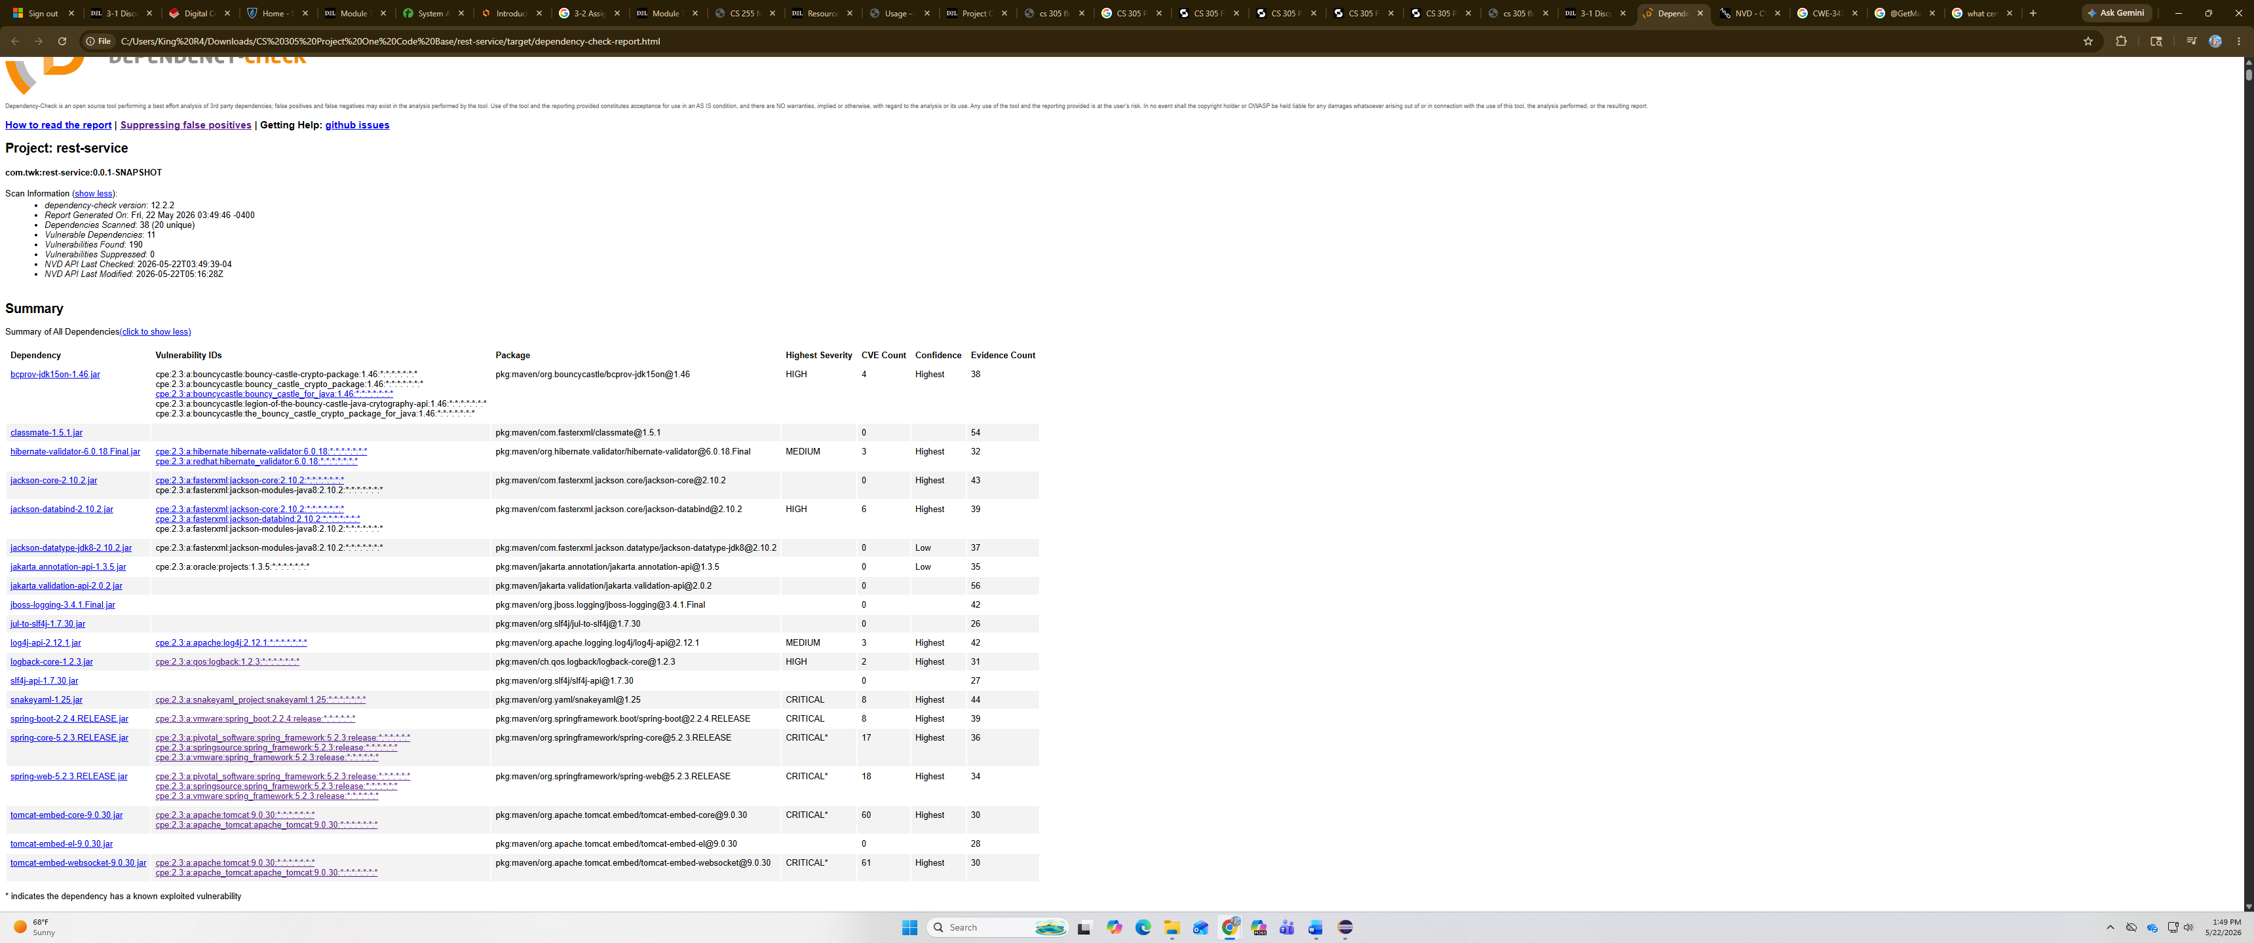

5. Mitigation Plan
Interpret the results from the manual review and static testing report. Then identify the steps to mitigate the identified security vulnerabilities for Artemis Financial’s software application.

To mitigate identified security vulnerabilities for Artemis Financials software application, ensuring proper input validation, error handling, encapsulation, API usage, and cryptography is critical. Prioritizing vulnerabilities by ranking is also essential, as it can show the potential impact and exploitability of them. Maintaining high quality code is another important action, this will prevent data exposure and ensure secure interactions. Overall making sure everything is updated to the newest versions to protect against known or recently patched vulnerabilities. Continuous monitoring and regular audits are also recommended.

